Плейбук установки freeipa для серверов применён.
Учётные записи v.zakharichev, a.shepelev созданы во FreeIPA и доступ по ssh, sudo к хостам для этих учёток через FreeIPA предоставлен.

https://m1-freeipa01p.unix.tcsbank.ru/ipa/ui/
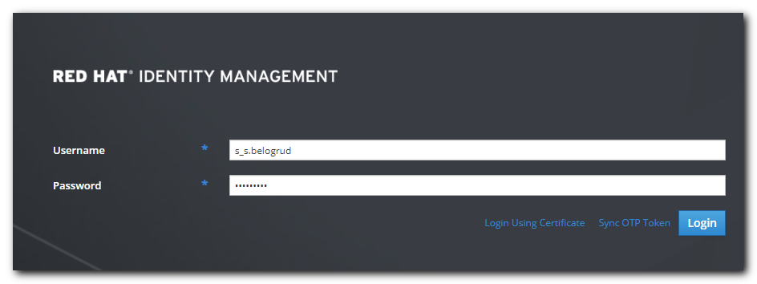

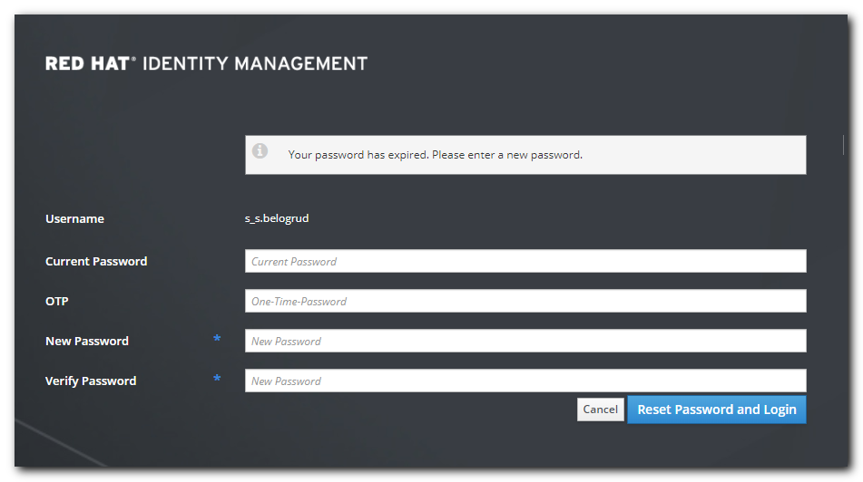

# I’ve entered same old password into all fields.
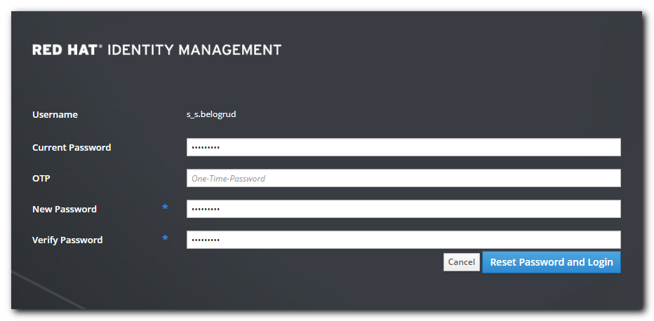

https://wiki.tcsbank.ru/pages/viewpage.action?spaceKey=TECHSUPPORT&title=HOW+TO+FREEIPA&focusedCommentId=589300485&refresh=1578924574765#comment-589300485

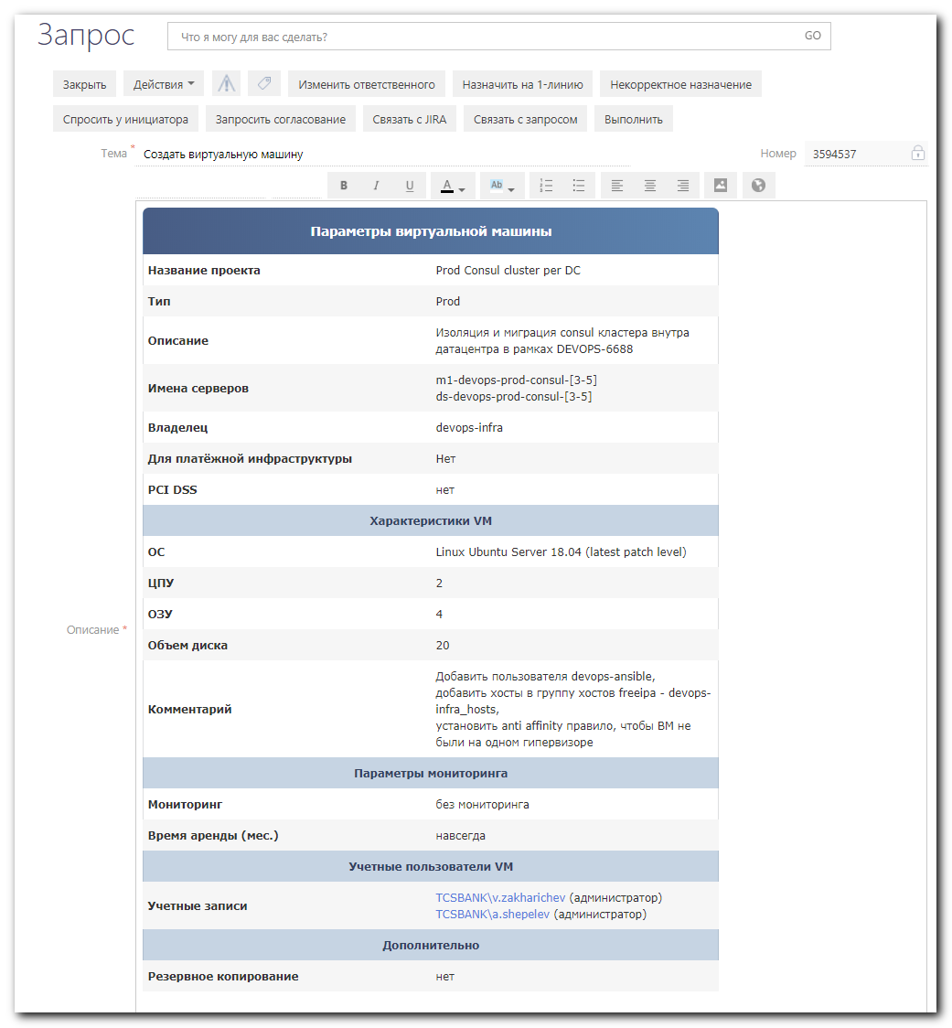
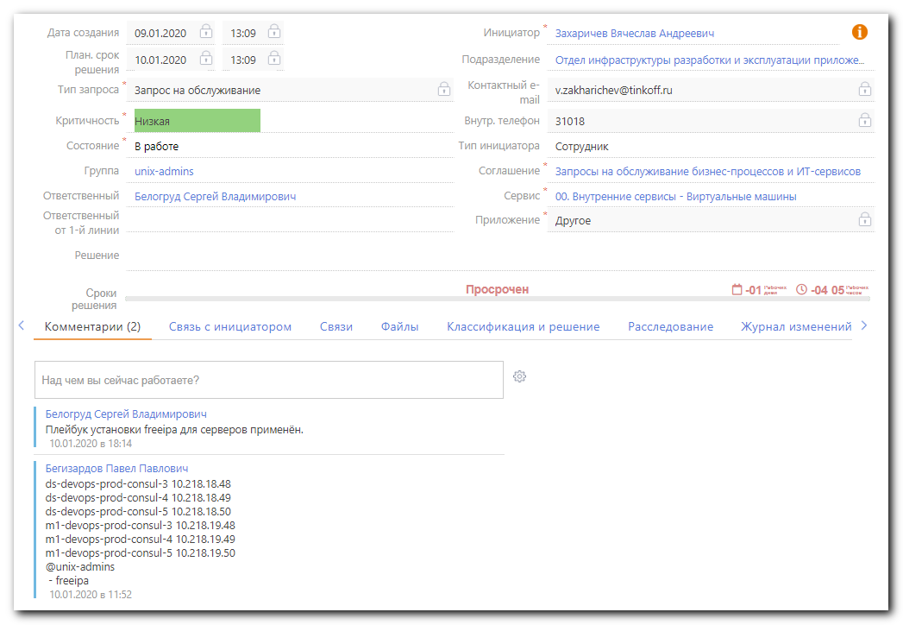

{
"users": [
"v.zakharichev",
"a.shepelev",
],
"hosts": [ds-devops-prod-consul-3, ds-devops-prod-consul-4, ds-devops-prod-consul-5, m1-devops-prod-consul-3, m1-devops-prod-consul-4, m1-devops-prod-consul-5],
"base_name": "devops-infra_hosts"
}

{"users":["v.zakharichev", "a.shepelev",],"hosts":[ds-devops-prod-consul-3, ds-devops-prod-consul-4, ds-devops-prod-consul-5, m1-devops-prod-consul-3, m1-devops-prod-consul-4, m1-devops-prod-consul-5],"base_name": "devops-infra_hosts"}

https://apple.stackexchange.com/questions/121817/how-to-fix-curl-60-ssl-certificate-invalid-certificate-chain-when-using-sudo

https://adam.younglogic.com/2010/07/talking-to-freeipa-json-web-api-via-curl/
https://www.freeipa.org/page/API_Examples
https://stackoverflow.com/questions/48045605/curl-post-data-to-server-and-get-redirected-page/48046135
http://dkhramov.dp.ua/Comp.GetPostWithCurl#.Xhxoj8gzYwE
https://unix.stackexchange.com/questions/515483/how-to-send-a-file-for-single-post-parameter-with-curl

https://vda.li/en/posts/2015/05/28/talking-to-freeipa-api-with-sessions/

[s.belogrud@TCS4357]# curl -X POST -H "TOKEN: lWFeOvD3O0tumbmYid" https://unix-portal.tcsbank.ru/api/freeipa/
curl: (60) SSL certificate problem: self signed certificate in certificate chain
More details here: https://curl.haxx.se/docs/sslcerts.html

curl failed to verify the legitimacy of the server and therefore could not
establish a secure connection to it. To learn more about this situation and
how to fix it, please visit the web page mentioned above.
[s.belogrud@TCS4357]#

[s.belogrud@TCS4357]# curl --insecure -X POST -H "TOKEN: lWFeOvD3O0tumbmYid" https://unix-portal.tcsbank.ru/api/freeipa/
<h1>Server Error (500)</h1>[s.belogrud@TCS4357]#

[s.belogrud@TCS4357]# curl -v -X POST -H "TOKEN: lWFeOvD3O0tumbmYid" -k https://unix-portal.tcsbank.ru/api/freeipa/ -d b=@/tmp/post.json
Note: Unnecessary use of -X or --request, POST is already inferred.
* Trying 10.216.48.194:443...
* TCP_NODELAY set
* Connected to unix-portal.tcsbank.ru (10.216.48.194) port 443 (#0)
* ALPN, offering http/1.1
* Cipher selection: ALL:!EXPORT:!EXPORT40:!EXPORT56:!aNULL:!LOW:!RC4:@STRENGTH
* successfully set certificate verify locations:
* CAfile: /etc/pki/tls/certs/ca-bundle.crt
CApath: none
* TLSv1.2 (OUT), TLS header, Certificate Status (22):
* TLSv1.2 (OUT), TLS handshake, Client hello (1):
* TLSv1.2 (IN), TLS handshake, Server hello (2):
* TLSv1.2 (IN), TLS handshake, Certificate (11):
* TLSv1.2 (IN), TLS handshake, Server key exchange (12):
* TLSv1.2 (IN), TLS handshake, Server finished (14):
* TLSv1.2 (OUT), TLS handshake, Client key exchange (16):
* TLSv1.2 (OUT), TLS change cipher, Change cipher spec (1):
* TLSv1.2 (OUT), TLS handshake, Finished (20):
* TLSv1.2 (IN), TLS change cipher, Change cipher spec (1):
* TLSv1.2 (IN), TLS handshake, Finished (20):
* SSL connection using TLSv1.2 / ECDHE-RSA-AES256-GCM-SHA384
* ALPN, server accepted to use http/1.1
* Server certificate:
* subject: C=RU; ST=Moscow; O=Tinkoff Bank; OU=IT; emailAddress=admins.tinkoff.ru
* start date: Sep 19 11:19:16 2018 GMT
* expire date: Sep 18 11:19:16 2023 GMT
* issuer: DC=ru; DC=tcsbank; CN=VM-CAENT-SUB02
* SSL certificate verify result: self signed certificate in certificate chain (19), continuing anyway.
> POST /api/freeipa/ HTTP/1.1
> Host: unix-portal.tcsbank.ru
> User-Agent: curl/7.65.0
> Accept: */*
> TOKEN: lWFeOvD3O0tumbmYid
> Content-Length: 17
> Content-Type: application/x-www-form-urlencoded
>
* upload completely sent off: 17 out of 17 bytes
* Mark bundle as not supporting multiuse
< HTTP/1.1 500 Internal Server Error
< Server: nginx/1.12.2
< Date: Mon, 13 Jan 2020 13:10:31 GMT
< Content-Type: text/html; charset=utf-8
< Content-Length: 27
< Connection: keep-alive
< X-Frame-Options: SAMEORIGIN
<
* Connection #0 to host unix-portal.tcsbank.ru left intact
<h1>Server Error (500)</h1>[s.belogrud@TCS4357]#

https://adam.younglogic.com/2010/07/talking-to-freeipa-json-web-api-via-curl/

[s.belogrud@TCS4357]# curl -k https://unix.tcsbank.ru/ipa/config/ca.crt > /tmp/ipa.ca.cert

[s.belogrud@TCS4357]# cat /tmp/ipa.ca.cert
<!DOCTYPE HTML PUBLIC "-//IETF//DTD HTML 2.0//EN">
<html><head>
<title>301 Moved Permanently</title>
</head><body>
<h1>Moved Permanently</h1>
<p>The document has moved <a href="http://ds-freeipa01p.unix.tcsbank.ru/ipa/config/ca.crt">here</a>.</p>
</body></html>
[s.belogrud@TCS4357]#

[s.belogrud@TCS4357]# curl -k http://ds-freeipa01p.unix.tcsbank.ru/ipa/config/ca.crt > /tmp/ipa.ca.cert
% Total % Received % Xferd Average Speed Time Time Time Current
Dload Upload Total Spent Left Speed
100 4474 100 4474 0 0 35228 0 --:--:-- --:--:-- --:--:-- 35228
[s.belogrud@TCS4357]# head /tmp/ipa.ca.cert
-----BEGIN CERTIFICATE-----
MIIDFTCCAf2gAwIBAgIQYfwqlBM7SqxDST+voPXt2TANBgkqhkiG9w0BAQsFADAd
MRswGQYDVQQDExJUSU5LT0ZGQkFOSy1ST09UQ0EwHhcNMTYwNjE2MTEwMjAzWhcN
MzYwNjE2MTExMjAzWjAdMRswGQYDVQQDExJUSU5LT0ZGQkFOSy1ST09UQ0EwggEi
MA0GCSqGSIb3DQEBAQUAA4IBDwAwggEKAoIBAQCmIJhRHJAPD7nVbo0kDLSCeb2F
iWWoHTN75hMvtw3SlXgJ3FmYCvmjQzVjENfE2VA/5J0hL/I2u6CvfaNReGPKWn3E
ER/hakYGwLodxcxDWBozTf7aPxPodFOGDiRoIW5D+3bM9Dw1pG1okJGf+YO1St5n
wbXJfPPzEFqsBZ0TBVpB3sgVkOlKprjmLA7IMhCwMtGv5/EZpBJzAzz5i1TbFRfm
pfP5q77HHlEuhagJb+aBRNKJ3Mo42cDt3VfoZQ3ldIH4UehXkWpDxejtwGZkoD7I
Qxcrwe1Xm8opVoVYckQA/ppuDGy2r/1lJUFJK3skz7ftlC9OkWguTAhelHu7AgMB
[s.belogrud@TCS4357]#

[s.belogrud@TCS4357]# curl -v -X POST -H "TOKEN: lWFeOvD3O0tumbmYid" -H "Content-Type:application/json" -H "Accept:applicaton/json" --negotiate -u : --cacert /tmp/ipa.ca.cert https://unix-portal.tcsbank.ru/api/freeipa/ -d '{"users":["v.zakharichev", "a.shepelev",],"hosts":[ds-devops-prod-consul-3, ds-devops-prod-consul-4, ds-devops-prod-consul-5, m1-devops-prod-consul-3, m1-devops-prod-consul-4, m1-devops-prod-co-5],"base_name": "devops-infra_hosts"}'

curl -v -X POST -H "TOKEN: lWFeOvD3O0tumbmYid" -H "Content-Type:application/json" -H "Accept:applicaton/json" --cacert /tmp/ipa.ca.cert https://unix-portal.tcsbank.ru/api/freeipa/ -d '{"users":["v.zakharichev", "a.shepelev",],"hosts":["ds-devops-prod-consul-3",],"base_name":"devops-infra_hosts"}'

[support@centos work]$ curl -X POST -H "TOKEN: ****" -d '{"users":["v.zakharichev","a.shepelev"],"hosts":"ds-devops-prod-consul-3","base_name":"devops-infra_hosts"}' -k https://unix-portal.tcsbank.ru/api/freeipa/
<h1>Server Error (500)</h1>
[support@centos work]$

#
# A way via Chrome plugin “Talend API Tester - Free Edition”.
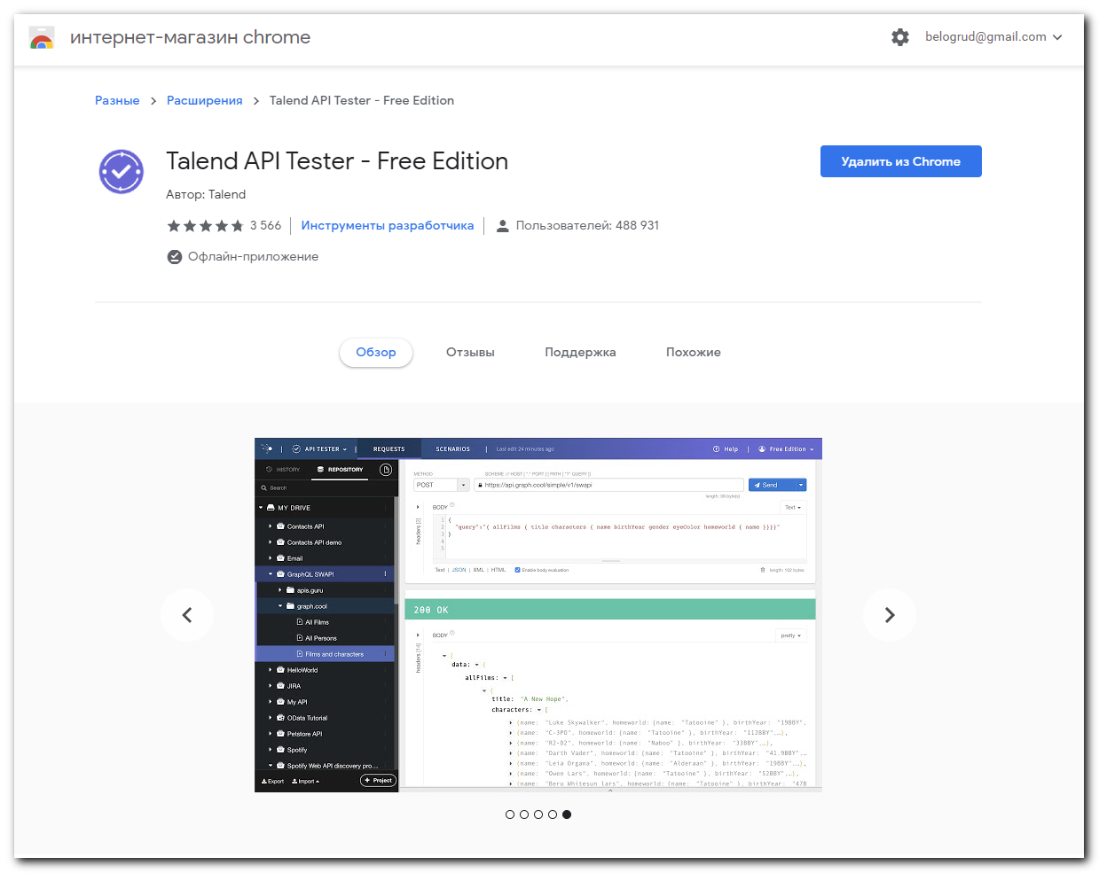

# Here is how to open Chome plugin shop.
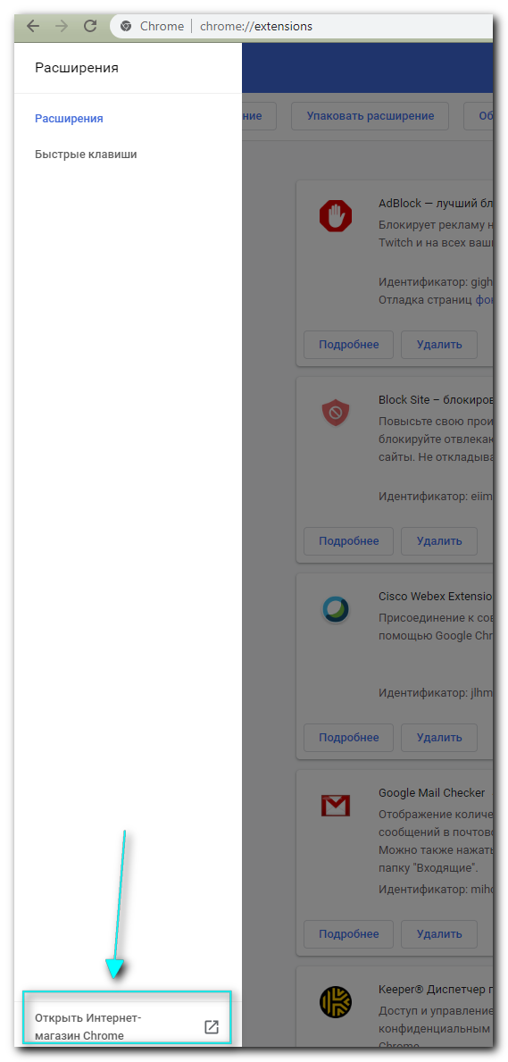

#
# Хосты нужно указывать в FQDN имени.
# Иначе результат команды будет ОК (код 200) но поскольку в FreeIPA хосты без суффикса домена отсутствуют - не будет сделано ничего.
# Во FreeIPA FQDN хосты и хосты без доменного суффикса - это разные хосты. Там жесткое соответствие по имени.

# В Json описании нужно убирать последние запятые в списках. Иначе - привет ошибка 500.

# Если указан список "sudoers", то список "users" не нужнен. Итак пользователи будут созданы и им дано право sudo.

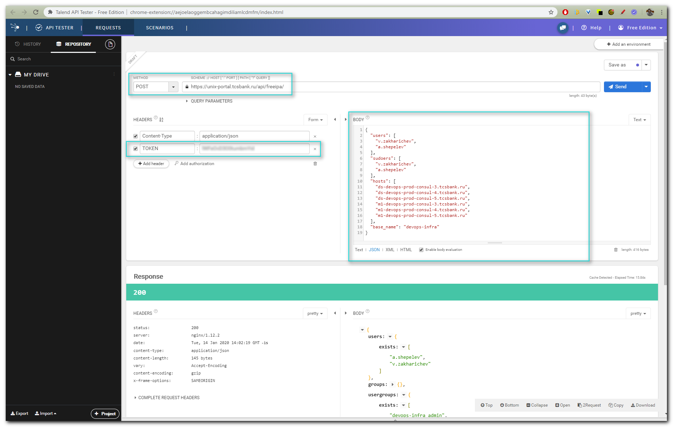
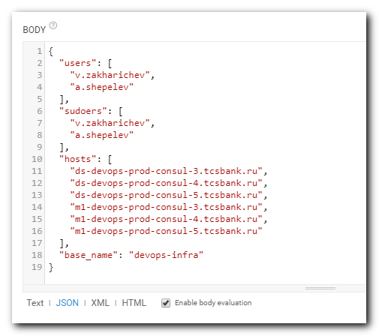

{
"users": [
"v.zakharichev",
"a.shepelev"
],
"sudoers": [
"v.zakharichev",
"a.shepelev"
],
"hosts": [
"ds-devops-prod-consul-3.tcsbank.ru",
"ds-devops-prod-consul-4.tcsbank.ru",
"ds-devops-prod-consul-5.tcsbank.ru",
"m1-devops-prod-consul-3.tcsbank.ru",
"m1-devops-prod-consul-4.tcsbank.ru",
"m1-devops-prod-consul-5.tcsbank.ru"
],
"base_name": "devops-infra"
}

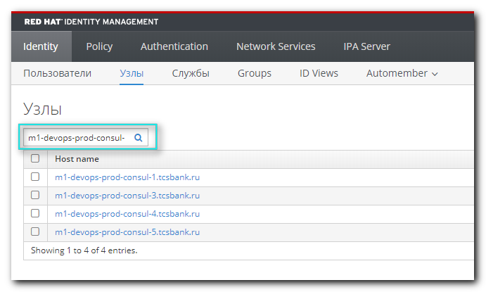
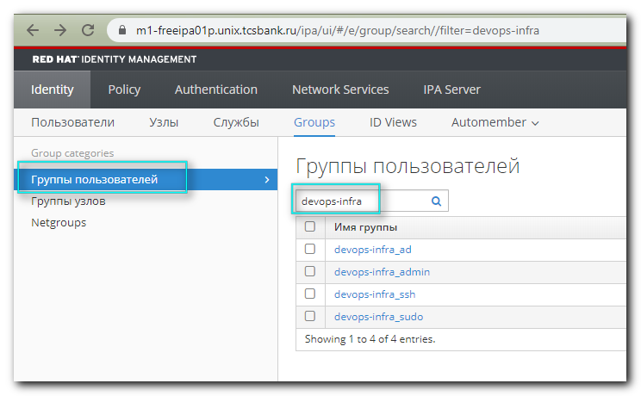
# If push on “devops-infra_ssh”.
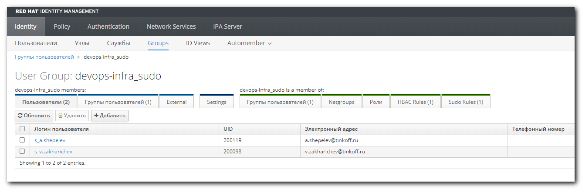

#
# Examples with working command line.
# But ony need to change hostnames to FQDN.
#

# На текущий момент только одно API доступно для использования на unix-portal.tcsbank.ru/api/freeipa/
# И нет возможности обратиться к тестовому API чтобы оно вернуло “Ок”, чтобы быть уверенным, что системы получения данных через API во FreeIPA работают корректно. А, например, ошибка в синтаксисе команды.
#

[s.belogrud@TCS4357]# curl -v -X POST -H "TOKEN: lWFeOvD3O0tumbmYid" -d '{"users": ["v.zakharichev","a.shepelev"], "hosts": ["ds-devops-prod-consul-3"], "base_name": "devops-infra"}' -k https://unix-portal.tcsbank.ru/api/freeipa/
Note: Unnecessary use of -X or --request, POST is already inferred.
* Trying 10.216.48.194:443...
* TCP_NODELAY set
* Connected to unix-portal.tcsbank.ru (10.216.48.194) port 443 (#0)
* ALPN, offering http/1.1
* Cipher selection: ALL:!EXPORT:!EXPORT40:!EXPORT56:!aNULL:!LOW:!RC4:@STRENGTH
* successfully set certificate verify locations:
* CAfile: /etc/pki/tls/certs/ca-bundle.crt
CApath: none
* TLSv1.2 (OUT), TLS header, Certificate Status (22):
* TLSv1.2 (OUT), TLS handshake, Client hello (1):
* TLSv1.2 (IN), TLS handshake, Server hello (2):
* TLSv1.2 (IN), TLS handshake, Certificate (11):
* TLSv1.2 (IN), TLS handshake, Server key exchange (12):
* TLSv1.2 (IN), TLS handshake, Server finished (14):
* TLSv1.2 (OUT), TLS handshake, Client key exchange (16):
* TLSv1.2 (OUT), TLS change cipher, Change cipher spec (1):
* TLSv1.2 (OUT), TLS handshake, Finished (20):
* TLSv1.2 (IN), TLS change cipher, Change cipher spec (1):
* TLSv1.2 (IN), TLS handshake, Finished (20):
* SSL connection using TLSv1.2 / ECDHE-RSA-AES256-GCM-SHA384
* ALPN, server accepted to use http/1.1
* Server certificate:
* subject: C=RU; ST=Moscow; O=Tinkoff Bank; OU=IT; emailAddress=admins.tinkoff.ru
* start date: Sep 19 11:19:16 2018 GMT
* expire date: Sep 18 11:19:16 2023 GMT
* issuer: DC=ru; DC=tcsbank; CN=VM-CAENT-SUB02
* SSL certificate verify result: self signed certificate in certificate chain (19), continuing anyway.
> POST /api/freeipa/ HTTP/1.1
> Host: unix-portal.tcsbank.ru
> User-Agent: curl/7.65.0
> Accept: */*
> TOKEN: lWFeOvD3O0tumbmYid
> Content-Length: 108
> Content-Type: application/x-www-form-urlencoded
>
* upload completely sent off: 108 out of 108 bytes
* Mark bundle as not supporting multiuse
< HTTP/1.1 200 OK
< Server: nginx/1.12.2
< Date: Tue, 14 Jan 2020 13:32:47 GMT
< Content-Type: application/json
< Content-Length: 297
< Connection: keep-alive
< Vary: Accept-Encoding
< X-Frame-Options: SAMEORIGIN
<
* Connection #0 to host unix-portal.tcsbank.ru left intact
{"users": {"exists": ["a.shepelev", "v.zakharichev"]}, "groups": {}, "usergroups": {"exists": ["devops-infra_admin", "devops-infra_ssh", "devops-infra_sudo"]}, "hostgroups": {"exists": ["devops-infra_hosts"]}, "hbacs": {"exists": ["devops-infra_hbac"]}, "sudos": {"exists": ["devops-infra_sudo"]}}[s.belogrud@TCS4357]#
[s.belogrud@TCS4357]#

[s.belogrud@TCS4357]# curl -v -X POST -H "TOKEN: lWFeOvD3O0tumbmYid" -d '{"users": ["v.zakharichev","a.shepelev"], "hosts": ["ds-devops-prod-consul-3","ds-devops-prod-consul-4","ds-devops-prod-consul-5","m1-devops-prod-consul-3","m1-devops-prod-consul-4","m1-devops-prod-co-5"], "base_name": "devops-infra"}' -k https://unix-portal.tcsbank.ru/api/freeipa/
Note: Unnecessary use of -X or --request, POST is already inferred.
* Trying 10.216.48.194:443...
* TCP_NODELAY set
* Connected to unix-portal.tcsbank.ru (10.216.48.194) port 443 (#0)
* ALPN, offering http/1.1
* Cipher selection: ALL:!EXPORT:!EXPORT40:!EXPORT56:!aNULL:!LOW:!RC4:@STRENGTH
* successfully set certificate verify locations:
* CAfile: /etc/pki/tls/certs/ca-bundle.crt
CApath: none
* TLSv1.2 (OUT), TLS header, Certificate Status (22):
* TLSv1.2 (OUT), TLS handshake, Client hello (1):
* TLSv1.2 (IN), TLS handshake, Server hello (2):
* TLSv1.2 (IN), TLS handshake, Certificate (11):
* TLSv1.2 (IN), TLS handshake, Server key exchange (12):
* TLSv1.2 (IN), TLS handshake, Server finished (14):
* TLSv1.2 (OUT), TLS handshake, Client key exchange (16):
* TLSv1.2 (OUT), TLS change cipher, Change cipher spec (1):
* TLSv1.2 (OUT), TLS handshake, Finished (20):
* TLSv1.2 (IN), TLS change cipher, Change cipher spec (1):
* TLSv1.2 (IN), TLS handshake, Finished (20):
* SSL connection using TLSv1.2 / ECDHE-RSA-AES256-GCM-SHA384
* ALPN, server accepted to use http/1.1
* Server certificate:
* subject: C=RU; ST=Moscow; O=Tinkoff Bank; OU=IT; emailAddress=admins.tinkoff.ru
* start date: Sep 19 11:19:16 2018 GMT
* expire date: Sep 18 11:19:16 2023 GMT
* issuer: DC=ru; DC=tcsbank; CN=VM-CAENT-SUB02
* SSL certificate verify result: self signed certificate in certificate chain (19), continuing anyway.
> POST /api/freeipa/ HTTP/1.1
> Host: unix-portal.tcsbank.ru
> User-Agent: curl/7.65.0
> Accept: */*
> TOKEN: lWFeOvD3O0tumbmYid
> Content-Length: 234
> Content-Type: application/x-www-form-urlencoded
>
* upload completely sent off: 234 out of 234 bytes
* Mark bundle as not supporting multiuse
< HTTP/1.1 200 OK
< Server: nginx/1.12.2
< Date: Tue, 14 Jan 2020 13:35:59 GMT
< Content-Type: application/json
< Content-Length: 297
< Connection: keep-alive
< Vary: Accept-Encoding
< X-Frame-Options: SAMEORIGIN
<
* Connection #0 to host unix-portal.tcsbank.ru left intact
{"users": {"exists": ["a.shepelev", "v.zakharichev"]}, "groups": {}, "usergroups": {"exists": ["devops-infra_admin", "devops-infra_ssh", "devops-infra_sudo"]}, "hostgroups": {"exists": ["devops-infra_hosts"]}, "hbacs": {"exists": ["devops-infra_hbac"]}, "sudos": {"exists": ["devops-infra_sudo"]}}[s.belogrud@TCS4357]#

[s.belogrud@TCS4357]# curl -X POST -H "TOKEN: lWFeOvD3O0tumbmYid" -d '{"users": ["v.zakharichev","a.shepelev"], "hosts": ["ds-devops-prod-consul-3","ds-devops-prod-consul-4","ds-devops-prod-consul-5","m1-devops-prod-consul-3","m1-devops-prod-consul-4","m1-devops-prod-co-5"], "base_name": "devops-infra"}' -k https://unix-portal.tcsbank.ru/api/freeipa/
{"users": {"exists": ["a.shepelev", "v.zakharichev"]}, "groups": {}, "usergroups": {"exists": ["devops-infra_admin", "devops-infra_ssh", "devops-infra_sudo"]}, "hostgroups": {"exists": ["devops-infra_hosts"]}, "hbacs": {"exists": ["devops-infra_hbac"]}, "sudos": {"exists": ["devops-infra_sudo"]}}[s.belogrud@TCS4357]#

